Fake News or Real News : A Modern Conundrum in the Digital Age

Christine Chow
Kavin Somu
Nihar Ullal
Grace Mika

Abstract
As misinformation becomes more pervasive online, distinguishing fake news from real news is critical. This project investigates whether machine learning models, leveraging natural language processing (NLP) and statistical features, can effectively classify news articles as real or fake. Using the WELFake dataset, we engineered features such as article length, headline punctuation, and sentiment, and applied Term Frequency-Inverse Document Frequency (TF-IDF) to represent text data numerically. We implemented multiple classifiers such as Logistic Regression, Naïve Bayes, and ensemble stacking models and evaluated them with Monte Carlo cross-validation. Our findings show that models using TF-IDF and engineered features perform significantly better than those using either alone, with the ensemble model achieving the highest accuracy (96.1%) and AUC-ROC (0.993). These results suggest that combining stylistic and linguistic cues with strong modeling approaches offers a viable method for automatic fake news detection.

Introduction
As social media continues to dominate news consumption, political polarization deepens, and sensational headlines become the norm, distinguishing factual reporting from misinformation has become an increasingly difficult challenge. Even accurate news stories can be distorted—intentionally or not—leading to a media environment where trust is eroded and truth is often blurred. In this context, the ability to automatically assess the credibility of news content is not just a technical task but a societal necessity.
This project aims to build a classification model capable of distinguishing between real and fake news articles based on textual content and auxiliary features such as article length, headline length, and the number of capitalized words in headlines. We integrated natural language processing (NLP) techniques with classification modeling to identify linguistic patterns and statistical features that may help differentiate factual articles from fabricated ones. Our research is guided by the following research questions (RQ):
RQ1: Can fake news be distinguished from real news based on the language of the news source?
RQ2: Are NLP models effective at identifying linguistic patterns of real and fake news?
RQ3: With what degree of accuracy can models classify a news article as real or fake? What models and inputs have the highest predictive accuracy?
Answering these questions will provide technical insight into model performance and shed light on underlying language differences between real and fake news. As misinformation spreads rapidly and widely online, building effective models for automatic fake news detection becomes critical to promoting reliable information and supporting media literacy.
The task of fake news detection presents several key challenges:
- Unstructured Text Data: News articles are composed of unstructured textual content, making feature extraction non-trivial. Meaningful patterns must be derived from high-dimensional and sparse text representations.
- Linguistic Subtlety: Linguistic differences between real and fake news can be nuanced. Both may use emotional language, making it difficult to draw clear decision boundaries.
- Feature Selection: Choosing appropriate features—both from text (e.g., word usage, sentiment) and metadata (e.g., headline structure)—is critical for effective classification.
- Overfitting Risk: Due to the high dimensionality of text data and potentially correlated features, there is risk of overfitting, especially if the model captures superficial patterns.
- Class Balance and Bias: While our dataset is balanced, real-world applications often are not. Ensuring that models generalize well beyond training data is a core challenge.
To address these challenges, we adopted a multi-step methodical approach, beginning with text preprocessing. We applied NLP techniques including tokenization, stopword removal, and lemmatization to clean and standardize the textual data. Tokenization breaks the text content into “tokens” consisting of individual words. Stopword removal narrows the focus to meaningful words by eliminating filler words which do not carry much meaning and would not be unique to one class or the other; for example, words such as “the,” “and,” and “is”. The lemmatization step transforms words to their base form, or lemma, allowing variations of a word to be grouped together as a single concept; for example, “presidential” becomes “president.” These steps reduce noise and improve the quality of downstream feature extraction.
We next explored feature engineering to account for and incorporate article characteristics beyond raw text. We engineered additional features such as article length, headline word count, and capitalization metrics, which may signal stylistic cues which differ between fake or real news. We used Term Frequency-Inverse Document Frequency (TF-IDF) to numerically represent word importance across documents, helping the model distinguish between common and contextually significant terms. TF-IDF identifies important words by weighing their frequency relative to their occurrence across documents, enabling better feature extraction. TF-IDF will be discussed in more detail in the proposed methodology section.
Subsequently, we conducted the modeling and evaluation phase, in which we implemented and compared multiple classification models—Logistic Regression, Linear Discriminant Analysis (LDA), and Quadratic Discriminant Analysis (QDA)—chosen for their interpretability and effectiveness in binary classification. To reduce overfitting and ensure model stability, we used Monte Carlo cross-validation, which averages results across multiple random train/test splits. We evaluated model performance using metrics like accuracy, precision, recall, F1 score, and ROC-AUC. To further optimize performance, we experimented with different model inputs, observing their impact on training and test results.
The remainder of this report is structured as follows:
- Data Sources & Exploratory Data Analysis introduces the dataset and its features.
- Proposed Methodology outlines our methodology, including preprocessing, feature engineering, and the rationale for our model choices.
- Analysis & Results presents the analysis and key findings from our modeling efforts.
- Conclusion presents reflections on our results, limitations, and suggestions for future work, as well as lessons learned throughout the project.
In this report, we hope to demonstrate the effectiveness of NLP-based classification of fake news—and to contribute toward broader efforts to safeguard truth in the digital age.
- Data Sources & Exploratory Data Analysis
We sourced our dataset from Kaggle, an online data science platform. Our selected dataset, Word Embedding over Linguistic Features for Fake News Detection (WELFake), was compiled as part of doctoral research and made public to other researchers. The WELFake data was produced by combining articles from four popular news datasets including Kaggle, McIntire, Routers and BuzzFeed Political. The dataset is composed of 72,134 news articles, of which 51.4% (n= 37, 106) are deemed to be “real news,” grounded in truth, and 48.6% (n= 35,028) are deemed to be “fake news” which have been fabricated or misleadingly exaggerated [1]. The dataset includes four variables: a unique article ID, title, text content, and a binary label: 1 for real and 0 for fake. The text column averages 3,000 characters or about 500 words per article.
We performed exploratory analyses with the aim of extracting relevant features from the dataset to enhance our models. We explored the distributions of the title word count, the text word count, the number of fully capitalized title words, title punctuation, and sentiment analysis.
Visualizations of word count distributions can be found in Figure 1A of the Appendix. The Title Word Count histogram reveals fake news articles had slightly shorter titles, with lengths of 8-12 words appearing with the highest frequency. In contrast, real news articles commonly had slightly longer titles, peaking around 10–15 words. Despite this, the considerable overlap indicates title length may have limited power to distinguish reliably between real and fake news.
The Text Word Count histogram from Figure A1 shows a clearer distinction: real news articles generally exhibit greater length, with many containing 500–1,000 words and several extending beyond this range, indicating detailed reporting. Fake news articles, conversely, are mainly shorter, concentrated around 250–750 words. This noticeable difference suggests article length could serve as a more predictive indicator in our modeling efforts, potentially helping classifiers more accurately identify articles as real or fake. These observations underscore the potential value of text length features as complementary signals alongside linguistic and semantic characteristics for fake news classification.
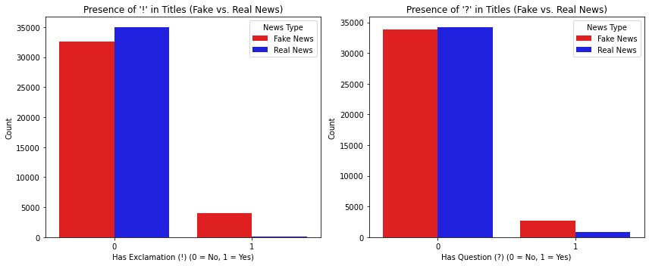
Next, we explored the use of punctuation– particularly exclamation points (!) and question marks (?)-- within titles to determine if distinct patterns of usage emerge. Figure 1 illustrates the distribution of punctuation usage in article titles. The frequency of exclamation points in fake news titles is shown to be far higher than in real news titles, with 5,000 more exclamatory titles than real news. For question marks, the discrepancy in punctuation usage is of a slightly lower degree but still notable, with 3,000 more fake news articles’ titles containing question marks as compared to real news. This shows fake news often uses punctuated sensationalist or “clickbait” headlines to shock and draw in readers.

Figure 1. Title Punctuation Distribution.
We next conduct sentiment analysis using VADER and TextBlob with the aim of identifying patterns or trends in sentiment across real versus fake news articles. VADER is an NLP technique to identify and derive the sentiments (negative, neutral, or positive) expressed in text data, and was used for title sentiment analysis [3]. We used TextBlob to compute a sentiment score for the body text. TextBlob assigns a polarity value from -1 (extremely negative) to +1 (extremely positive) to each article, allowing us to represent the emotional tone of each article, as shown in Figure A3.
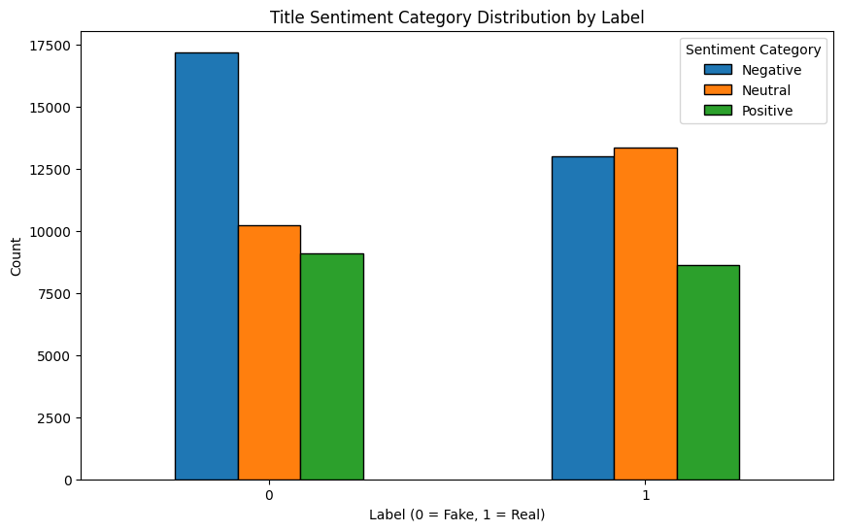
The Title Sentiment Category Distribution plot (Figure 2) provides insight into differences in the emotional tone, or sentiment, between real and fake news article headlines. Fake news headlines have a disproportionately high frequency of negative sentiment, suggesting fake articles often rely on emotionally charged, negative language, potentially to provoke stronger reader engagement or amplify sensationalism. In contrast, real news article titles exhibit a more balanced distribution between negative and neutral sentiment, which may reflect journalistic objectivity and less reliance on sensationalism. This indicates emotional sentiment in titles, especially negativity, could be a valuable discriminative feature in our modeling.

Figure 2. Title Sentiment Distribution by Label.
- Proposed Methodology
We adopted a four-tiered modeling strategy to incrementally incorporate more complex textual features for fake news classification. This approach progresses from simple exploratory features to advanced text representations, and finally to an ensemble model, allowing us to compare performance at each level. All experiments were implemented in Python with a fixed random seed for reproducibility. Below, we detail the data preprocessing and feature engineering steps, the models built in each tier, and our model evaluation protocol.
We first cleaned and standardized the news text data. All article titles and bodies were converted to lowercase and stripped of extraneous characters, punctuation and stop words to reduce noise. Certain punctuation and capitalization information was preserved temporarily for feature extraction. This standardization ensured variations in capitalization or punctuation beyond what we intentionally capture as features would not skew the text-based model inputs.
From the cleaned text, we engineered a set of hand-crafted features to capture stylistic and content cues that might differentiate fake news from real news. Specifically, we extracted:
- Title Length: Number of words in the headline (title).
- Article Length: Number of words in the body text.
- Title Capitalization: Count of fully capitalized words in the title.
- Punctuation Presence: Binary indicators for whether the title contains exclamation marks (!) or question marks (?).
- Title Sentiment: Sentiment polarity score of the title (VADER).
- Body Sentiment: Sentiment polarity score of the article text (TextBlob).
These features were inspired by patterns reported in fake news literature. For example, fake news titles contain more fully capitalized words compared to real news titles, and tend to use excessive punctuation to grab attention [5], which was confirmed through our exploratory data analysis. By including title length and capitalized word count, we capture these stylistic cues. We also flag exclamation and question marks as a proxy for sensational or interrogative style often seen in clickbait and fake headlines. In addition, we incorporated sentiment scores– which has been used in prior fake news detection research– because fake news often exaggerates emotional tone to engage readers [6].
After extracting these features, we transformed the textual content into a vectorized representation. We used a Term Frequency-Inverse Document Frequency (TF-IDF) vectorizer to encode the article body text into numerical features. TF-IDF is a method commonly used in text analysis to measure how important a word is to a specific document, especially in comparison to other documents [3]. Term Frequency measures how often a word appears in a particular document; if a word shows up more frequently, it is likely to be more relevant to the document’s main topic [3]. Inverse Document Frequency measures how rare a word is across all documents. If a word appears in many documents, it is probably a common word which will be minimally helpful in distinguishing between article classes. If a word is rare, it is considered more meaningful for distinguishing that document. When combined, TF-IDF scores each word based on how often it appears and how unique it is [3], resulting in higher weights for words that are frequent in a given article but rare across the collection of articles [4]. For computational efficiency and to reduce overfitting, we limited the TF-IDF features to the top 1000 terms by frequency, yielding a 1000 dimensional sparse feature vector per article, representing important vocabulary. We did not include the title in the TF-IDF, since the title is short and partly captured by EDA features. The TF-IDF matrix was combined with EDA features in one modeling tier.
Tier 1: EDA Features Only
In the first tier, we trained baseline models using only the EDA features described above. This allowed us to assess how well simple linguistic and metadata features alone distinguish fake vs. real news, establishing a baseline against which we can compare more feature-rich approaches.. We evaluated four algorithms: logistic regression, linear discriminant analysis, quadratic discriminant analysis, and gaussian naive bayes. Explanations are in A6.
Each model in Tier 1 was first trained on a training set, using an 80/20 train-test split of the data. We evaluated initial performance using accuracy (overall proportion of correct predictions) of the testing dataset. This provided a sense of which algorithms and feature signals were most promising. Given the limited feature set, we expected the performance to be modest, but this tier establishes a baseline for comparison with more complex models.
To obtain more robust estimates and account for variance due to data splitting, we applied Monte Carlo cross-validation– specifically, a ShuffleSplit cross-validator–to perform 10 random train–test splits of the data​ [8]. Averaging results over these iterations, yields a more reliable assessment of model accuracy and variability​ [8]. For Tier 1, as well as subsequent tiers, we tracked not only accuracy but also precision, recall, F1-score, and ROC-AUC. We will discuss these metrics and results in detail in the evaluation section, and an additional explanation of metrics is included in A4 of the Appendix.
Tier 2: EDA + TF-IDF Features
In the second tier, we expanded the feature set to include text content features in addition to EDA features. The 1000-dimensional TF-IDF vector of the article body concatenated with the original EDA feature vector served as input for each model of this tier. Tier 2 aims to assess whether incorporating the full vocabulary signals from the text improves fake news detection performance beyond the baseline. If the language used in fake vs. real news cis distinctive, the models should achieve higher accuracy with these features.
We employed the same set of four classifiers for direct comparability: LR, LDA, QDA, and GN. However, now the input feature space is much larger with more than 1000 features. We expected logistic regression and Naïve Bayes to handle this high-dimensional input well; logistic regression with appropriate regularization can weight the important terms, and Naïve Bayes is a common choice for text classification [4]. LDA and QDA, on the other hand, face challenges in high dimensions and might not perform as well, but we included them for completeness in observing how a generative approach copes with the richer feature set.
We carefully prepared the data before feeding it to the models. The TF-IDF features were processed to be numbers within a similar range, making them suitable to use with logistic regression and Naive Bayes models without additional adjustments. We exhibited caution in LDA and QDA, as these models can struggle if there are too many features compared to the number of samples. To prevent issues, we ensured our dataset had enough observations to handle the features included. We utilized an 80/20 train split and Monte Carlo cross-validation and evaluated models with the aforementioned metrics.
We expected the models using TF-IDF features to perform much better in correctly identifying fake news, with higher recall and a higher AUC-ROC score, because TF-IDF features allow models to recognize specific words or phrases commonly found in fake articles. We retained the simpler features like title length and sentiment scores to see if they provide additional classification benefit. Improvements in this tier would confirm specific words and phrases in articles enhances classification beyond surface-level features alone.
Tier 3: TF-IDF Features Only
The third tier uses only the TF-IDF feature matrix as input, omitting EDA features. Tier 3 aims to isolate the contribution of the text content. By comparing Tier 3 to Tier 2, we determine whether the EDA features add meaningful value beyond the TF-IDF representation. It also serves as a pure text classification baseline, common in fake news detection research [5].
We trained the same four classifiers (LR, LDA, QDA, GNB) on the TF-IDF vectors. Logistic regression was expected to perform strongly, as it can effectively handle sparse high-dimensional data by learning weights for each term​ [4]. LDA and QDA were included to observe their behavior, though we expected LDA’s performance to possibly degrade without the EDA features unless the patterns of word usage clearly differ between real and fake articles.
Evaluation for Tier 3 mirrored the prior tiers: we used the same train/test split for an initial accuracy measurement, followed by 10 iterations of Monte Carlo cross-validation to compute the range of metrics. If Tier 3’s results are close to Tier 2, it would imply the EDA features had limited additional predictive power beyond the text itself. Conversely, if Tier 2 outperforms Tier 3, it would justify our inclusion of those exploratory features as complementary signals.
Throughout all three tiers, we plotted ROC curves for each model to inspect true positive vs false positive trade-offs, and confirm whether one model dominated another.
Tier 4: Stacking Ensemble Model
Finally, we developed a stacking ensemble model to combine the strengths of multiple classifiers. Ensemble methods are known to often improve predictive performance by leveraging different algorithms’ complementary strengths​ [7]. Based on results of earlier tiers, we selected two models as base learners: Logistic Regression and Multinomial Naïve Bayes (MNB). Logistic regression demonstrated robust performance with EDA and TF-IDF features, while Naïve Bayes is a generative approach well-suited to word frequency data. The intuition was that logistic regression and NB might capture different aspects of the data: NB can be very sensitive to the presence of certain strong indicator words, whereas logistic regression weighs combinations of features for optimal separation [7]. If one model makes errors on certain articles the other gets right, a stacked model can learn to correct those by considering both predictions.
These two base models were trained on the full TF-IDF feature set. We opted to use a larger TF-IDF vocabulary, the top 5000 items, to provide as much information as possible about the language patterns. We increased the features in this final step because ensembles can handle more complexity without overfitting as quickly, and we wanted to capture potentially informative rarer terms. We focused exclusively on text content and did not include EDA features. A logistic Regression model was the meta-learner in our stack, which weighs the “opinion” of the LR vs the NB when making a final prediction for a given news article; it inputs the outputs of the base learners to compute a final prediction. We chose logistic regression because of its ability to learn a well-calibrated combination of base models’ predictions, and to avoid overfitting we kept it relatively simple with no deep or highly nonlinear meta-learner.
To train the stacked model without introducing bias, we used an internal cross-validation approach on the training data: each base model was fit on a portion of the training set and evaluated on a hold-out fold to generate predictions for the meta-learner. After training, we evaluated the stacking ensemble using the 10-fold Monte Carlo cross-validation procedure and computed performance metrics. We expected the stacking model to outperform any individual model from the previous tiers, as stacking has been shown to achieve higher accuracy than single classifiers in various text classification tasks​ [7]. The inclusion of two base learners that likely have different error patterns provides an opportunity for the meta-learner to correct mistakes. For instance, if Naïve Bayes misclassifies an article due to the presence of a misleading keyword, the logistic regression might override that prediction based on other features, and vice versa.
- Analysis & Results
To evaluate our models, we adopted a structured approach, progressively enhancing complexity by incorporating more detailed textual information and ultimately combining the strengths of different methods through ensemble modeling. Below, we summarize the most significant findings and key insights from our analysis. We focus primarily on the performance of logistic regression and the stacking ensemble model, as these yielded the best overall results.
Initially, we tested models using only basic exploratory features, such as word counts, punctuation, and sentiment, to determine if these simpler indicators were enough to distinguish real news from fake news effectively. Our results indicated that logistic regression performed best among the initial set of classifiers.
Performance Summary: Tier 1 Features
 | Accuracy | Precision | Recall | F1 Score | AUC-ROC
Logistic Regression | 73.5% | 69.4% | 82.2% | 0.752 | 0.783
LDA | 74.1% | 67.1% | 92.5% | 0.778 | 0.781
QDA | 71.9% | 64.4% | 95.2% | 0.769 | 0.816
Naive Bayes | 72.0% | 64.4% | 95.3% | 0.769 | 0.807
While LDA and QDA as well as Naive Bayes achieved high recall around 95%, they resulted in lower precision, meaning they frequently misclassified real news articles as fake. Logistic regression offered the best balance, minimizing such errors. Logistic Regression had higher precision compared to LDA and a better AUC-ROC score, meaning it was better at identifying fake articles and was more effective at distinguishing real from fake articles overall. Additionally, because logistic regression clearly indicates how each feature contributes to predictions, its results were easier to understand and interpret compared to LDA or QDA.
Incorporating TF-IDF features in Tier 2 models significantly improved accuracy, as the models were better equipped to detect unique linguistic patterns associated with fake news. When combining TF-IDF with the Tier 1 features, logistic regression again emerged as the strongest performer, substantially improving across all performance metrics.
Performance Summary: Tier 2 Features
 | Accuracy | Precision | Recall | F1 Score | AUC-ROC
Logistic Regression | 95.5% | 95.4% | 95.4% | 0.954 | 0.991
LDA | 94.9% | 95.1% | 94.3% | 0.947 | 0.989
QDA | 87.8% | 89.1% | 85.6% | 0.873 | 0.951
Gaussian Naive Bayes | 85.8% | 86.8% | 83.7% | 0.852 | 0.919
This highlights the power of advanced feature engineering in terms of including TF-IDF, as each metric increased from 10-20%. Once again, QDA and Naive Bayes show high recall around 95%, but lower precision, suggesting they might produce many false positives. Logistic regression produced the highest performance metrics in every category in Tier 2, implying it’s the most stable and consistent model so far.
In Tier 3, we isolated the TF-IDF features and excluded the Tier 1 exploratory features. Logistic regression maintained high performance, but its metrics were lower than when combined with the exploratory features. This highlights that exploratory features added value by complementing textual information.
Performance Summary: Tier 3 Features
 | Accuracy | Precision | Recall | F1 Score | AUC-ROC
Logistic Regression | 94.3% | 94.6% | 93.6% | 0.941 | 0.986
LDA | 93.7% | 94.5% | 92.6% | 0.935 | 0.986
QDA | 86.3% | 86.7% | 85.2% | 0.859 | 0.943
Gaussian Naive Bayes | 84.2% | 84.3% | 83.3% | 0.838 | 0.907
Logistic regression remains dominant. Gaussian Naive Bayes, typically strong with text data, underperformed with an accuracy of 84.2%, likely due to Gaussian assumptions not suited to sparse text data. This was expected as logistic regression is known to handle sparse, high dimensional TF-IDF data effectively and robustly, unlike QDA [4].
Finally, we applied the stacking ensemble method, combining predictions from logistic regression and Naive Bayes models into a more robust model. This approach outperformed all previous models, achieving the highest accuracy and most balanced performance metrics.
Performance Summary: Stacking Ensemble Model
 | Accuracy | Precision | Recall | F1 Score | AUC-ROC
Stacking Ensemble | 96.1% | 96.3% | 95.7% | 0.960 | 0.993
The stacking model leveraged the complementary strengths of both base models: logistic regression effectively captured subtle linguistic patterns, while Naive Bayes excelled at identifying key indicator words. The combination proved superior, demonstrating the value of ensemble approaches. As shown in the AUC-ROC graphs (Figure 3), the stacking ensemble method has the highest prediction threshold, even when compared to the stronger curves in the Tier 2 graphs, included in Figure A5 in the Appendix.
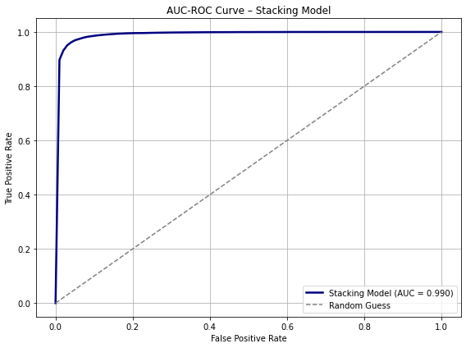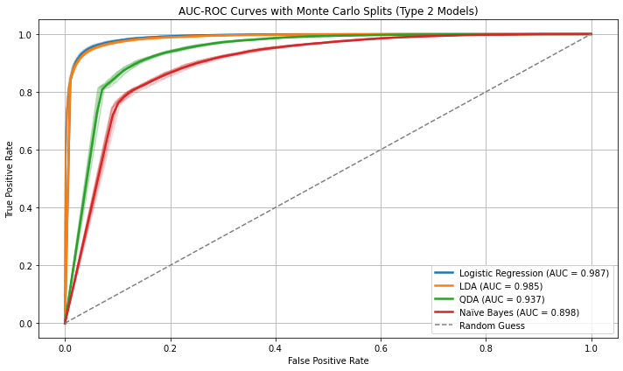
Figure 3. AUC-ROC Curves.
- Conclusion
Our analysis confirms fake news articles exhibit detectable patterns in both content and style, and that machine learning models can successfully learn to distinguish them from real news. Simple exploratory features such as article length, sentiment, and punctuation usage provide moderate predictive power on their own. However, when combined with TF-IDF representations of article text, model performance improves dramatically. Logistic Regression consistently performed best across tiers, and the stacking ensemble further enhanced performance by blending strengths from different classifiers. These results highlight the value of integrating multiple feature types and modeling approaches. While promising, our models are trained on a curated dataset and may face challenges when generalized to noisy, real-world data. Future work should focus on expanding to other datasets to ensure broader applicability. Nonetheless, this project demonstrates that automated fake news detection is effective when built on strong data and good model and feature selection.
Lessons We Have Learned
This project taught us that well-engineered features paired with the right model can have promising results. Throughout this class and in our work, we also learned the importance of cross-validation in getting reliable performance metrics and avoiding overfitting. Finally, we saw that data mining is an iterative process of refining each step from preprocessing, EDA, feature selection, to model selection.

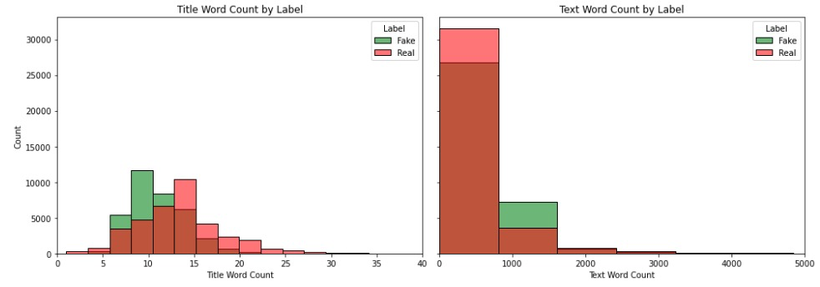
Appendix

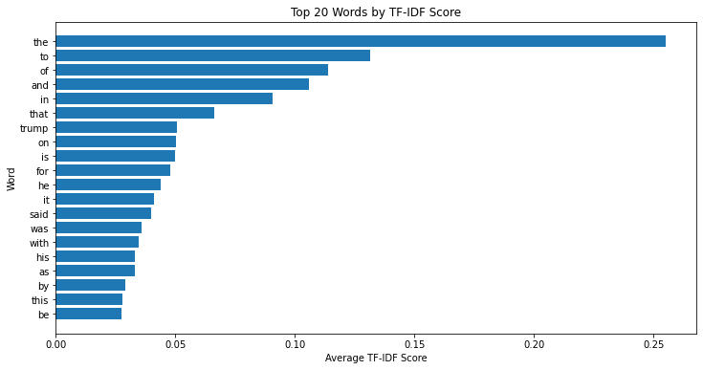
Figure A1. Title Word Count & Text Word Count.

Figure A2. Top 20 Words by TF-IDF Score.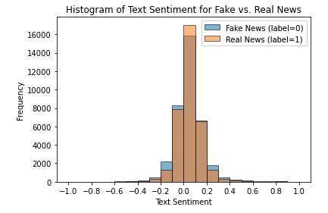
Figure A3. Article Body Text Sentiment.
A4. Metrics Definitions.
- Precision: measures the proportion of articles predicted as fake that are actually fake, indicating how trustworthy positive predictions are [9].
- Recall: reflects the ability of the model to correctly identify fake articles, showing how effectively the model detects positives overall [9].
- F1 Score: Combines precision and recall into a single balanced metric, giving an overall sense of model accuracy when classes might be uneven [9].
- AUC-ROC: Represents how well the model distinguishes between real news and fake news articles across all prediction thresholds, where a higher value indicates a better discrimination [9].
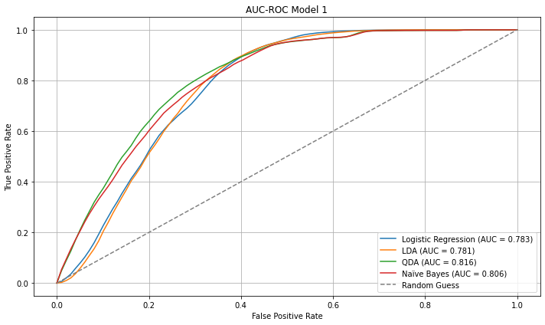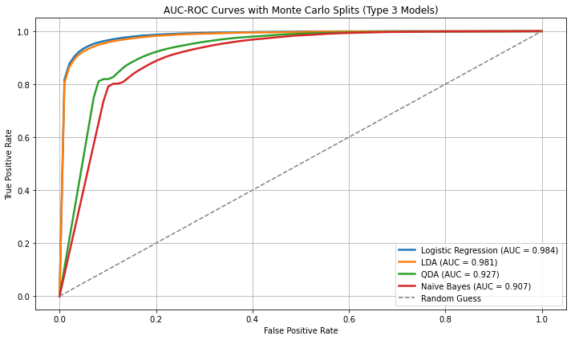
Figure A5. AUC-ROC Graphs.
A6. Definitions of 4 Classification Models Used.
- Logistic Regression (LR): A linear model that learns weights for each feature to directly predict the probability of an article being fake. We chose logistic regression as a strong baseline due to its efficiency and well-known performance on text classification tasks [4]. It can handle feature combinations and is less likely to overfit when the feature set is small and meaningful.
- Linear Discriminant Analysis (LDA): A generative classifier that assumes each class’s features follow a Gaussian distribution with a shared covariance [9]. LDA finds a linear boundary that best separates the classes. We included LDA to see how a probabilistic linear classifier performs relative to logistic regression, and because it can sometimes work well with limited numeric features by modeling class spread [9].
- Quadratic Discriminant Analysis (QDA): Similar to LDA but allows each class to have its own covariance matrix, leading to a quadratic decision boundary [9]. QDA can capture nonlinear interactions between the EDA features (e.g., a combination of title length and sentiment) that might distinguish fake news. However, it requires more data to estimate additional parameters, so this was an exploratory inclusion to test for any non-linear separability [9].
- Gaussian Naïve Bayes (GNB): A Bayesian classifier that assumes features are independent and Gaussian-distributed [10]. Despite its simplifying assumptions, Naïve Bayes often performs reasonably for text classification by leveraging class-conditional likelihoods. We used the Gaussian variant here, which is appropriate for continuous features like lengths and sentiment score, as a lightweight baseline to compare against the discriminative models. Its fast training and low complexity make it a useful reference point [10].

Works Cited
- Shahane, S. (n.d.). Fake news classification. Kaggle. https://www.kaggle.com/datasets/saurabhshahane/fake-news-classification
- IJAEM. (n.d.). Fake news detection using logistic regression. International Journal of Advanced Engineering and Management. https://ijaem.net/issue_dcp/Fake%20News%20Detection%20Using%20Logistic%20Regression.pdf
- Hex. (n.d.). VADER sentiment analysis. https://hex.tech/templates/sentiment-analysis/vader-sentiment-analysis/
- Singh, A., et al. (2021). Fake news detection using logistic regression & multinomial naïve Bayes. International Research Journal of Engineering and Technology (IRJET), 8(4). https://www.irjet.net
- Pérez, C., et al. (2020). Textual characteristics to detect fake news: A reproducibility study. In Misinfo 2020. https://par.nsf.gov
- Monti, E., et al. (2021). Sentiment analysis for fake news detection. Electronics. https://www.mdpi.com
- Liu, D., et al. (2020). Improvement of naïve Bayes text classifier based on ensemble. In Proceedings of the 2020 International Conference on Machine Learning and Applications (ICMLA). https://www.atlantis-press.com
- Li, A. (2023). Cross-validation methods: K-Fold, Monte Carlo, and Bootstrap. Medium. https://medium.com
- James, G., Witten, D., Hastie, T., & Tibshirani, R. (2021). An introduction to statistical learning: With applications in R (2nd ed.). Springer. https://www.statlearning.com
- Murphy, K. P. (2012). Machine learning: A probabilistic perspective. MIT Press. https://probml.github.io/pml-book

